|  |
| --- |
| NSW Traffic Penalty - Executive Summary |
| Group 69 - Member Names: Vy Dang – s5245519 You-ru-lu – s5217748 Pouya Yazdani – s52840162810ICT Software TechnologiesOctober 8, 2023 |

# Abstract

An overview of the study performed on a dataset covering a 12-month period is given in this executive summary. The analysis includes a variety of elements, such as trends, sanctions, and offense specifics. To improve data interpretation, insights from a software program are also integrated. The report highlights important conclusions about crime trends, legislative issues, and financial ramifications. Key trends and patterns in the dataset are presented using visualizations produced by the software.

# This study seeks to offer decision-makers and stakeholders a succinct yet instructive glance into the thorough analysis carried out on the dataset. Introduction

This report primarily focuses on elucidating the features and functionality of the application we have developed, as well as examining its correlation with the "Australia NSW traffic penalty data" dataset spanning from 2011 to 2017. The dataset description outlines five key tasks integral to this analysis report. These tasks encompass gathering comprehensive information on all penalty cases, analyzing the distribution of cases within each offense code category, investigating cases detected through radar or camera-based systems based on offense descriptions, studying cases attributed to mobile phone usage violations, and scrutinizing trends related to seatbelt non-compliance.

.

Analysis 1 <View_Case_Penalty>  
for this data set, we chose the year 2012 – 2013:  
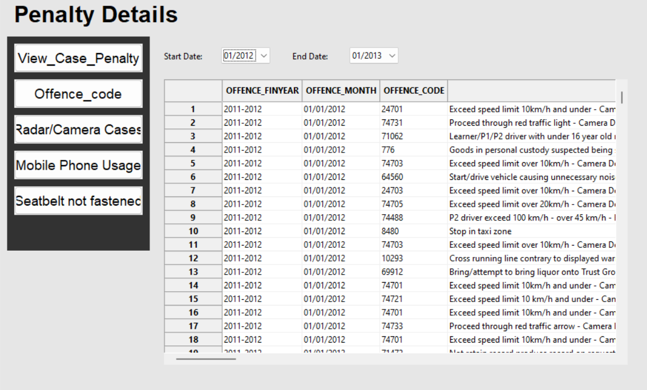

During this period, it systematically examines all the View_Case_Penalty records for NSW, beginning from the first month of the year and continuing through to the last month. Each record is uniquely characterized by a specialized description corresponding to a specific offense code that pertains to the specific circumstances of the crime. Furthermore, within the penalty cases, there is a comprehensive aspect of the crime description documented within the table's designated column.

# **Analysis 2 <** Offence_code **>**

for this data set, we chose the year 2012 – 2013:

In this dataset scenario, we have specifically selected offense code (74460), which is associated with the offense of "P1 driver exceeding 90 km/h - over 20 km/h - Radar." The table provided here illustrates the fluctuations observed over the course of the year. Vertically, it depicts the months of the year, while horizontally, it displays corresponding values. During the initial month, there is a notable decline in the number of individuals committing this offense. However, as the year progresses, this number steadily increases until it reaches a peak in the eighth month. Subsequently, there is a sharp decrease again, followed by another upward trend, culminating in the final month of the year.

# **Analysis 3 <** Radar/Camera Cases **>**

for this data set, we chose the year 2012 – 2013:

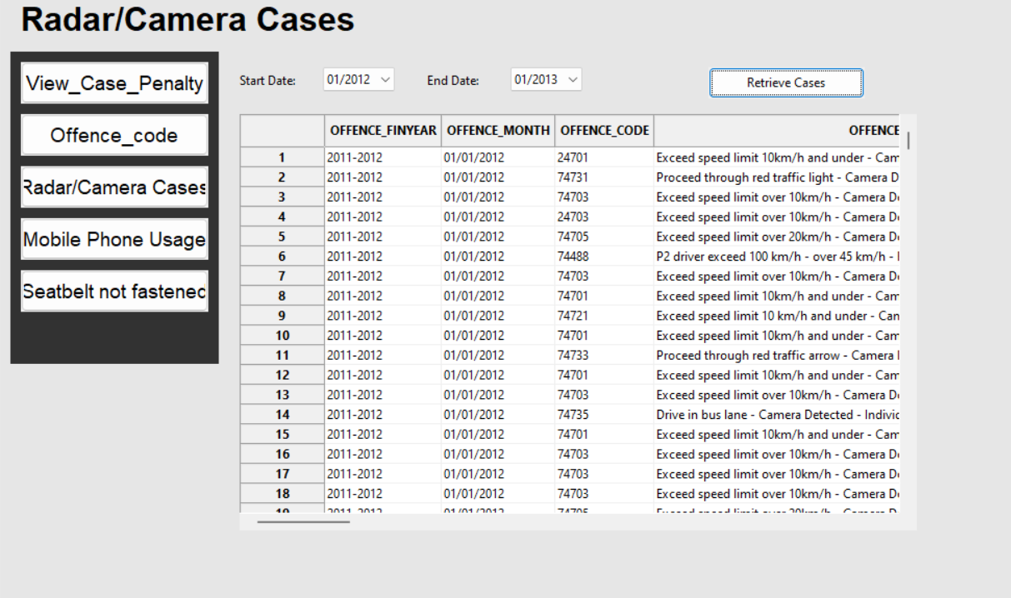

Within this dataset, the table serves as a representation of cases captured by radar and camera systems, encompassing all instances where crimes have been recorded through these means for NSW.

# **Analysis 4 <** Mobile Phone Usage **>**

for this data set, we chose the year 2012 – 2013:

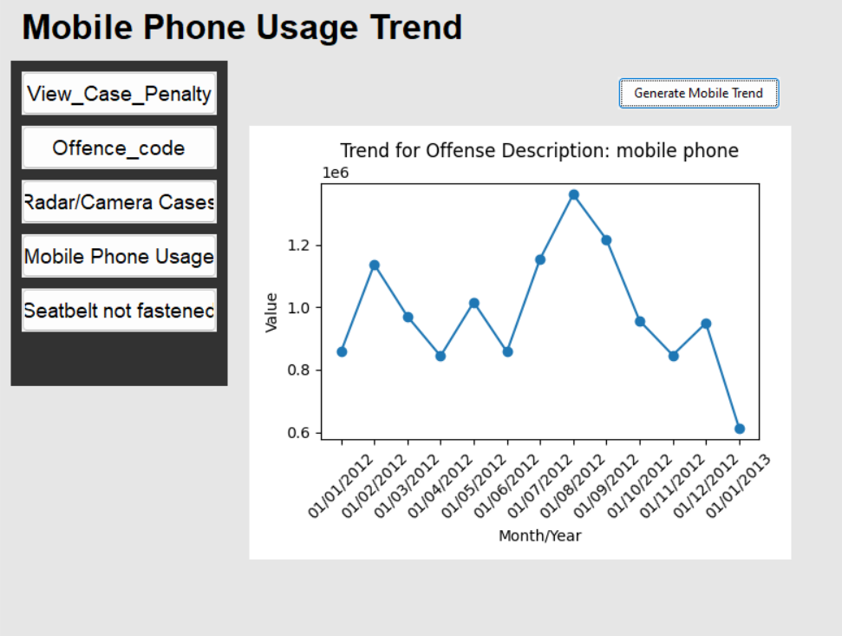

In this dataset, all the entries pertain to individuals who have committed the offense of using a phone while driving. During the initial six months of the year, the table depicts a relatively consistent average in such cases. However, there is a notable surge in offenses recorded between 01/06/2012 and 01/08/2012, followed by a sharp decline from that point until the end of the year.

# **Analysis 5 <** Seatbelt not fastened **>**

for this data set, we chose the year 2012 – 2013:  
  
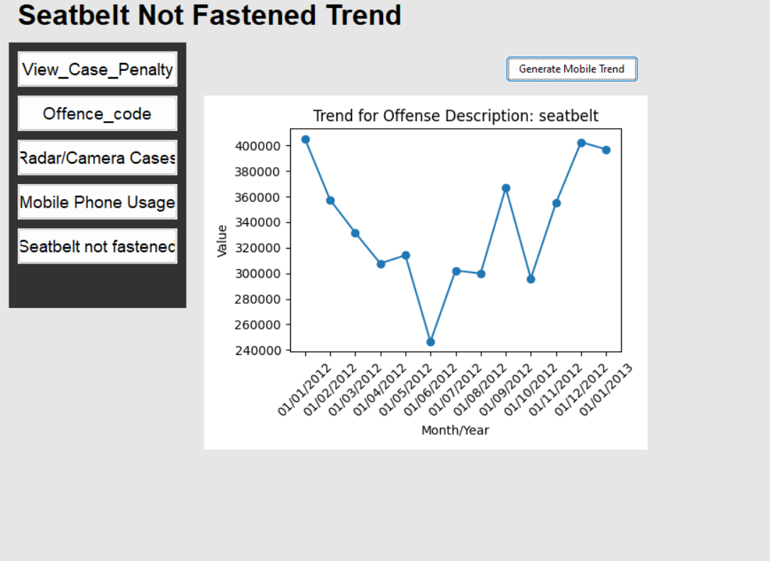

Within this dataset, the trend associated with the offense description pertaining to seatbelt violations is displayed in the table. The vertical axis represents the Month/year, while the horizontal axis represents the corresponding values. Notably, from the first month of the year until the fifth month, there is a sharp and continuous decline in values. However, starting from the fifth month and extending until the end of the year, there is a steady and incremental increase in values.